Variable

In C++, a variable is a named storage location that can hold a value of a particular data type. Variables are used to store data temporarily during program execution. They allow you to work with data in your program by giving it a meaningful name.

Here's the general syntax for declaring a variable in C++:

data_type variable_name;

Where “data_type” is the type of data the variable will hold (like int, float, char, etc.), and “variable_name” is the name you choose for the variable.

For example, to declare an integer variable named `age`, you would write:

int age;

This statement tells the compiler to allocate memory to store an integer value and name that memory location `age`.

You can also initialize a variable when you declare it, like this:

int age = 30;

This statement declares an integer variable named age and initializes it with the value 30.

Variables in C++ can be modified (i.e., their value can be changed) during program execution. This allows you to perform calculations, store user input, and manipulate data as needed in your program.

Data-type

In C++, a data type is a classification that specifies which type of value a variable can hold. It defines the size and layout of the variable's memory, the range of values that can be stored, and the operations that can be performed on it.

**Types of data types in C++**

1. *Built-in data types*
2. *derived data types*
3. *user-defined data types*

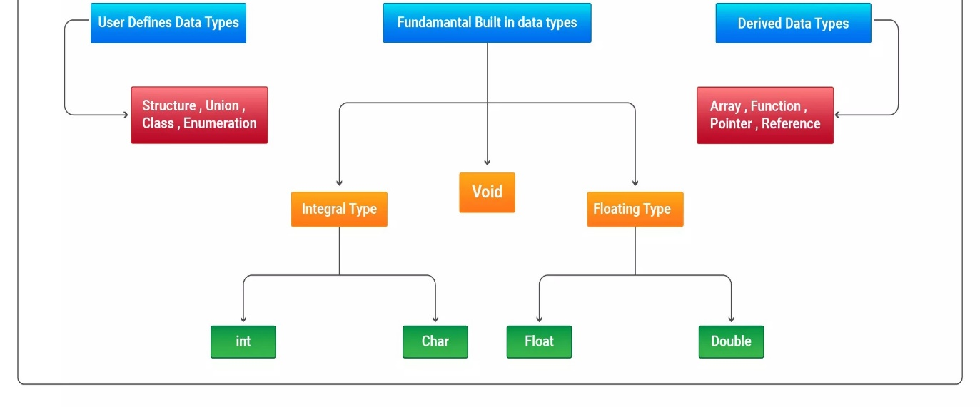

In C++, variables are used to store data values. Each variable has a specific data type, which determines the size and layout of the variable's memory, the range of values that can be stored, and the operations that can be performed on it. Here are some common data types in C++:

1. int: Used to store integers (whole numbers) like 1, 100, -5, etc. The size of an int is typically 4 bytes, which allows it to store values from -2,147,483,648 to 2,147,483,647.

2. float: Used to store floating-point numbers, which are numbers that have a decimal point or use an exponent (e.g., 3.14, -0.001, 1.0e10). Typically, a float occupies 4 bytes and can store numbers with up to 7 decimal digits of precision.

3. double: Similar to float but with double the precision. It typically occupies 8 bytes and can store numbers with up to 15 decimal digits of precision.

4. char: Used to store single characters (e.g., 'a', 'Z', '$'). It typically occupies 1 byte of memory.

5. bool: Used to store boolean values, which can be either true or false. The size of a bool is typically 1 byte.

6. void: Represents the absence of type. It is commonly used as the return type of functions that do not return a value, or as a placeholder for a generic type.

Here's an example of how variables are declared in C++:

int age = 30;

float pi = 3.14;

char grade = 'A';

bool isStudent = true;

We discuss derived and user defined data-type latterly in class.